* Facebook news engages the users more (more number of replies and reactions in general?). But these engagements are not necessarily related to the topic,many are insults, people trying to be funny, morbid humour. This is in spite of their comments being able to be seen by their friends/other people. Some people stick to the topic and try to calm down the comment section.
* YouTube has lesser engagement (need to check). It also has its share of trolls but fewer in number, most people stick to the topic. The comments are in general longer and more analytical in nature.
* “Facebook news is argued to be more efficacious in engaging consumers than promoting ideologies”. “YouTube can be said to be more effective in promoting ideologies than engaging consumers”. - <https://www.researchgate.net/publication/330142101_Critical_Multimodal_Discourse_Analyses_of_News_Discourse_on_Facebook_and_YouTube>
* Just reading the caption included with the news article link on Facebook allows for people to make their own interpretations of the news piece (introduces biases etc). Leads to less focussed, more divergent interactions. On the other hand, YouTube has the media included which will be played more often than not. This can change the perspective of the users and make their comments more to the point.
* Once the case developed and Rhea was brought into the picture, the number of replies considerably reduced compared to the initial news of SSR’s death, for both FB and YT. This could be because initially people had less information, less context, they were more shocked and volatile. But later as more evidence, witnesses and information in general came up, people were more comfortable in forming their own opinions, posting their comments, and skipping the interactions in other people’s comments.

‘

**Ratioed**

* India Today YT: 2 Comments, One was about ISI doing its work in killing SSR as people laughed when Afridi got Covid. The reply to this was also met with another insult/negative comment.The other was implying SSR would go to hell directly for committing suicide. Both are very negative comments. The reply to this was just an insult.
* “Han bhai kon bhonk rha tha afridi ke beemar hone pr... Krdya na ISI ne apna kaam ππ”
  + “shame on you.. every life is important”
* “Driect hellπππ­π­π­”
  + “Idiot”
* NDTV YT (Hindi): 1 Comment. Asking after successful movies, getting money why did he choose to do so. The reply asked for the meaning of a word, the OP told them the meaning and told them to google it next time (not sure if being rude or helpful).
* “I'm really saddened to hear that he is no more. I watched quite a few interviews of him he seemed like a really confident individual with full of life...... It's really sad what personal turmoil he or she suffer to take such an extreme measures Rest in peace man”
  + “He most of been killed no one will know his manager died week ago same way suicide”
* Times Now YT (Rhea Chak): 1 comment. Saying stop blaming Rhea for it, as SSR is not a kid. The reply to it was telling them not to ‘barking the wrong tree’ if they didn’t know the circumstances.
* “Shut up Shekar Suman..stop blaming Rhea for some one suicide..SSR is not a kid..he must be responsible...there should be nothing like abetment to death..every one are responsible for there own life...even if Rhea was not a good gf, that does not mean SSR had to commit suicide...if she was bad he had other options for life..death is not the solution for anything..stop media trail..let law take its own course!!”
  + “If u don't know anything about the circumstances at all stop barking the wrong tree ðŸ–•”
* Times Now FB: Few comments tagging their friends; asking if it's related to ex-manager’s death. One asking if this was due to no income. One reply agrees, another disagrees citing reasons. No negativity

The same reply which supports no income appears twice on other comments asking why. Another reply disagrees.

Another comment saying disgusting step, solution for everything. Reply saying it's easy to say, but difficult to come out of it. Another reply saying it's difficult, a lot of pressure, but he was educated.

A comment asking if this was due to lockdown. Few replies insulting the OP. Few saying have sympathy for the dead, annoyed by the insults in the comments.

Comment saying easy to portray MSD but can’t be a fighter like im IRL. Replies saying shameful comment, have sympathy, a little bit of insults etc.

Comment saying let him die no need to mourn as he didnt think of others when alive. Replies saying he donated, and another insulting the OP.

Few insults in the reply section, others mostly they speak about the topic and don’t go off topic.

* “How? Why? This is unbelievable”
  + “Onam Mukherjee Mitra Yes this true because of no income and no Film and a luxurious lifestyle..”
  + “Pynshailang Lynser Money isn't the reason.He already had lot of money.These celebrities always has to go through problems such as Media,affairs,people trolling them on social media.Anything can be the reason for suicide but money isn't.”
* “It's disgusting why people resort to these kind of suicides. There is a solution for everything. Sad to hear the news.”
  + “Raji Muthukrishnan mam it's easy to say this but one is in such a time that it's gets diffucuilt to come out of it .”
  + “I know sometimes the pressure is so much one is not able to handle the situation. But feel very sad. He was educated, could have done anything. Just pray for the soul.”
* “What is the main reason behind this suicide????”
  + “Chang K Kipging no more income”
  + “Chang K Kipging under investigation”
* Could this be another suicide due to severe depression exasperated by the lockdown . RIP🤔😢
  + Mohammed Ali Khan teri puncture shop open hai ya nahi?
  + Mohammed Ali Khan ya isme bhi modi ka haath hain vaise hi jaise tere paida hone main, baap banne main aur mamu banne main.
  + Please... A young man died Pls don't make comments
  + Mohammed Ali Khan No, this one's not at all related to Lock down. He was very successful, he could have survived lock down till his death even if he doesn't work.
  + can be......
  + Manish Gupta seriously........tumlog zara v nai hichakte kuch kehne se pehle......wat has come into people like you.......no humanity left at all
  + Priyesh Pandey I was only speculating but what is even more fascinating is that his manager had committed suicide 3 days ago. Is it a coincidence or is there something sinister involved. Time will tell, maybe.
  + Mohammed Ali Khan Yep, that's what I want to say. Let's wait for more details instead of baseless speculations.
  + Arpita Banerjee Bangali didi- go find attention somewhere else
  + Mohammed Ali Khan ,my dear, it was his ex manager not present manager, she was with her fiance and there is no scope for linking both as of now.
  + Mohammed Ali Khan Bhai...its time to pray
  + Prabir Banerjee You should pray as well.
* Easy to portray MS Dhoni on screen but not easy to be a fighter like him, be a fighter not a quitter OM SHANTI
  + Ritwik Dasgupta Shameful comment. Try typing 'Om Shanti' without insulting the person who just died
  + Stupidity knows no bounds
  + Ritwik Dasgupta get some positivity in life.......d man just died n here u r.....trying to b a professor
  + He died for sure but not sure its suicide....
* When he was alive he didn't think for other so let him die no use of mourning samething to other rich people also
  + Lalbiaksanga Molshoy Molshoy <https://www.google.co.in/amp/s/www.eastmojo.com/nagaland/2020/06/14/in-sushant-singh-rajputs-death-nagaland-lost-a-kind-soul>
  + Lalbiaksanga Molshoy Molshoy wt r u doing ....only blaming to others in yr whole life...u r born to go to helll
  + Shweta Jha he donated at kerala flood time also....n many more
* India Today FB: Few comments tagging friends. Few comments asking if it's real. Replies to those saying yes. Another comment saying poverty in India caused actors to commit (OP is a Pakistani). Replies are full of insults. Comment enquiring if it could be murder. Many replies agree with him. One says not suicide as he is a Sikh. Another says religion doesn’t matter. Comment trying to be funny saying SSR couldn’t tolerate being Covid positive. Many replies saying not funny and berating the OP. OP may be Pakistani, so replies using that to insult as well. Comment about a devil’s deal case (supernatural). Replies asking what is that and other replies trying to explain it.

Comment saying blame Pakistan now, and an insult in the reply. Comment saying he saw atrocities by INdian army at J&K. A lot of insults in the replies from both sides.

Comment saying he is going to hell and is again met by insult.

* Actors are also committing suicide in India due to poverty
  + โมฮัมมัด ราชิด เจ้าอาหรับ happy Porki
  + โมฮัมมัด ราชิด เจ้าอาหรับ abey o haram ki paidaish..bhonk mat idhar.
* This has happened a lot in past .murdered then labeled as suicide . RIP, Respect .
  + Aishwârya Rajput true I don't think it's a suicide attempt
  + Ali Raza Cheema he's a Sikh .its obvious.
  + Aishwârya Rajput doesn't matter his religion
  + Aishwârya Rajput he was an excellent actor and example for others how can he do this
  + Ali Raza Cheema he supported a freedom movement of Sikhs .
  + It's clearly a Murder Case
  + Ali Raza Cheema time will eventually reveal the truth .
  + Aishwârya Rajput of course
* He couldn't tolerate that he got positive for covid 19 .. decided to quiet his life
  + Waseem Ali it's not funny. Please act humane.
  + Waseem Ali tum sale hote hi madarchod ho, apne kom ka naam mitte mein mila ho tum jase kuch log. Saala kabhi milna kutte se chudwayenge tumhe.
  + Waseem Ali idiot person like you has got time to make fun on someone's death. 😠😠😠
  + Waseem Ali dude yeh confirmed news nahi hai toh yar yeh sab cheeze mat post kro.
  + @waseem Ali phle Afridi ko bacha lo beta he is positive ..
  + Waseem Ali aren’t you human ???
  + Waseem Ali for heavens..don't expose your inhuman sadistic behavior...by adding new canard to it....your mental state and lumpen mindset is getting exposed..he may be passing through some depression or personal issues..let's not be judgemental and intrusive about his private life.
  + Waseem Ali You are such shame to our society. How can you speak like this on someones death? One day you will also have taste it!
  + Suman Bunty Roy don’t bring religion here
  + Ramya Dave I will this shows what he thinks, I also mentioned it's bcoz of people like him whole community is targeted.
  + Umar Faruque Correct brother..
  + Waseem Ali what he could be cured oh no
  + Waseem Ali stop being a disgrace to your own society you twat. Someone has died here, sell your munjan somewhere else.
  + Waseem Ali Only a person without normal brain cells will find every tragic funny.You need help
* its a cross road demon deal case i think..he sold his soul 10yrs back to a crossroads demon in return for 10 yrs of life as he would want..
  + Aakash Nirmal what's that?
  + Garima Batra there is a supernatural process..u can summon a crossroads demon..these demons can grant ur wishes like wealth,over night succes fame etc anything u wish for..n in return they will give u 10yrs life.. after 10 yrs a hell hound comes n takes away ur soul..so i guess this case might be the same
  + Aakash Nirmal wtf man 🤔🤔
  + Raj Khan one of the possibilities bro .. celebraties dying all of a sudden..huge indications towards supernatural..chester Bennington,parveen bobby,sushant singh n so many more examples of famous successful celebrities who die suddenly all alone..behind these suicides lies the dark truth of supernatural activities..
  + This is why we are saying you so not watch horror movies a lot.
* Daldo ilzaam pakistan pr abtk ki bari khabr bna k
  + Vaibhav Shukla teri maa ki b.. Blky teri maa ki choot m mera loraa.. Ab sahe h lory jc shakal k
* Last he visited Indian Jammu & Kashmir the brutatlity he saw by Indian Occupied forces he got into depression finally hanging himself, likewise many indian army officials.
  + Nu'man Arif No he see brutality of Pak army in Baluchistan and in Kashmir
  + Nitish Singh Pangtey while he was wearing lundian army uniform #GayHind
  + Nu'man Arif wearing Porki army Terrorist Hope another plane crash on you
  + Nitish Singh Pangtey shame on you he must be burning in hell😂
  + Nu'man Arif your parents must be burning in hell What a shame Porki
* Good news he's Successfully reached to hell
  + Junaid Khan hey animal go die and rot in hell.
* Times Now FB (Rhea): Few comments are tagging friends, joking around.
* She said don’t quote me otherwise I will deny 🙄
  + Video aagya, Abb karo deny.
  + Pranaya Pranoy so now she is saying that this was a stand up act
  + Shivani Shastri Let people to judge that. Btw, any layman would say she was just modulating her voice and she said whatever she wanted to say from her heart in a drunken state.
  + Pranaya Pranoy true
* Jay Shah itne twists hai is case me i need ekta kapoor to make a movie, i cant keep up w the news anymore 😢
  + Vrinda Kabra getting drunk is a standup act?? Woww. Ekta kapoor banayegi toh nepo mein ginayegi movie. Ironic.
  + Jay Shah moral: dont get drunk. Listen to your parents 😤

**Bigrams**

* Times Now on YT contains comments more about Bollywood industry, acting, etc, Times Now on FB contains comments mostly about condolences.
* Similar for India Today, YT also contains ‘investigate’
* Times Now on FB (Rhea Chakroborty) contains ‘gold digger’,’true color’, and blames her mostly for the death of SSR. Times Now on YT contains ‘mumbai cbi/police’, etc and doesn’t as often explicitly blame Rhea for the death of SSR, it blames the industry.

**Polarity (TextBlob)**

* India Today YT:

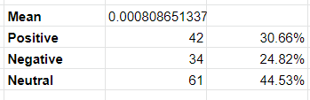

* India Today FB:

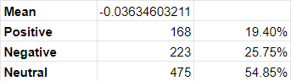

* Times Now YT:

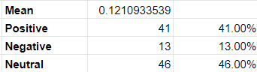

* Times Now FB:

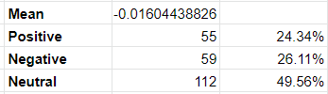

* India Today YT (Rhea Chakroborty):

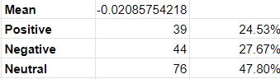

* Times Now YT (Rhea Chakroborty):

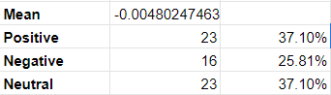

* Times Now FB (Rhea Chakroborty):

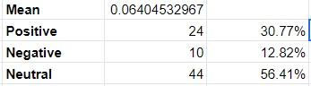

* More ‘positive sentiment’ words used in Times Now for the same news article as compared to India Today.
* More ‘negative sentiment’ words used in India Today for the same news article as compared to Times Now
* India Today YT, Times Now YT has more negative sentiment in case of Rhea chakraborty as compared to the initial news

**Sentiment Trend (TextBlob)**

* India Today FB shows a slight negative sloping trend as the date progresses. In the beginning mostly ‘rip’, tagging friends,’great actor’. In the end ‘terrible’, ‘sad’,’seriously’, longer sentences with ‘depression,suicide,weak’ etc.
* Times Now FB shows a minute (almost constant) positive sloping trend as date progresses
* Times Now FB (Rhea Chakraborty) shows a positive trend as date progresses: reasons could be phrases like - ‘not a **good** actress’, ‘**comedy circus**’,’funny’, etc which makes the sentiment positive. ['stop', 'make', 'fool', 'type', 'comedy', 'one', 'instead', 'go', 'movie', 'u', 'go', 'comedy', 'circus', 'like', 'u', 'r', 'good', 'actress', 'u', 'r', 'floop', 'absolutely', 'true', 'say', 'video'] got 0.525 sentiment because of words like comedy, good.
* India Today YT shows a slight upward trend with lots of ‘sad, tragic, criminal act’. In the end ‘great actor, talented, hard work intelligent’
* Times Now YT is almost flat. The positive sentiments come from comments like above.
* NDTV English and Hindi YT are both mostly flat.
* India Today YT (Rhea) is almost flat. The positive sentiments were coming from ‘kill good actor’,’do nice act award prison’,etc.
* Times Now YT (Rhea) has a slightly negative trend.
* NDTV YT (Rhea) trend seems to be positive mainly due to sarcastic comments like ‘Oscar worthy performance’, ‘nice acting’,’great contribution,best actress’, ’can't stop laughing’ and others like ‘truth will prevail’
* Facebook comments in the beginning are more of condolences and people at the end construct bigger sentences.
* YouTube comments are almost all bigger sentences distributed all over.
* This could be either because the current API doesn’t retrieve ALL of the comments, or because of the nature of the social media, Facebook being more of a ‘scrolling site’ (to see other videos we need to scroll away) and youtube being more media focussed (we can see other video recommended side by side along with the video, similarly with comments).

**Polarity (Vader)**

|  | **YouTube** | | | **Facebook** | | |
| --- | --- | --- | --- | --- | --- | --- |
|  | **Compound** | **Positive** | **Negative** | **Compound** | **Positive** | **Negative** |
| **India Today** | -0.09980066225 | 0.1301589404 | 0.1996622517 | -0.1157481522 | 0.109925 | 0.2118521739 |
| **Times Now** | 0.049405 | 0.16562 | 0.13992 | -0.1606233333 | 0.1077708333 | 0.2237375 |
| **NDTV English** | 0.0605535 | 0.1305 | 0.10381 |  |  |  |
| **NDTV Hindi** | 0.0108582 | 0.118056 | 0.122 |  |  |  |
| **India Today Rhea** | -0.006611042945 | 0.107208589 | 0.1298404908 |  |  |  |
| **Times Now Rhea** | -0.05101290323 | 0.1245645161 | 0.1319032258 | 0.06314556962 | 0.1143417722 | 0.09846835443 |
| **NDTV Rhea** | 0.245463 | 0.22256 | 0.08441 |  |  |  |

* India Today had, on an average, more negative sentiment on both FB and YT.
* Times now had almost an equal mix of negative and positive comments on YT, but more negative sentiment on Facebook
* NDTV English and Hindi had almost similar sentiments on Youtube
* Times Now, when Rhea was brought into the picture, showed more negative sentiment on YouTube, and showed more positive sentiment on Facebook.
* Times Now Rhea showed more negative sentiment than India Today Rhea. India Today was almost neutral.
* NDTV Rhea shows more positive sentiment compared to NDTV Hindi and NDTV English, which might imply that people hearing the loss of SSR had more negative/sad sentiment compared to the anger they had towards Rhea.

Mostly: +/-5, Upwards/Downwards: +/-4 ,Moderately: +/-3, Slightly: +/-2, Almost flat +/-1

| 5 Mins | YouTube | Facebook |
| --- | --- | --- |
| India Today | 1 | 2 |
| Times Now | 4 | -3 |
| NDTV English | 3 |  |
| NDTV Hindi | 1 |  |
| India Today Rhea | -1 |  |
| Times Now Rhea | -4 | 3 |
| NDTV Rhea | -3 |  |

| 10 Mins | YouTube | Facebook |
| --- | --- | --- |
| India Today | 1 | 2 |
| Times Now | 4 | -2 |
| NDTV English | 3 |  |
| NDTV Hindi | 1 |  |
| India Today Rhea | -2 |  |
| Times Now Rhea | -4 | 3 |
| NDTV Rhea | -2 |  |

| 30 Mins | YouTube | Facebook |
| --- | --- | --- |
| India Today | 1 | 1 |
| Times Now | 4 | 2 |
| NDTV English | -2 |  |
| NDTV Hindi | -2 |  |
| India Today Rhea | -2 |  |
| Times Now Rhea | -3 | 2 |
| NDTV Rhea | -1 |  |

* On YouTube the trend is negative when Rhea Chakraborty angle was brought into the picture for all news channels
* Trend for Times Now YT and FB are opposite (YT is increasing)
* Trends for Times Now Rhea Chak YT and FB are opposite (YT is decreasing)

**Synched**

* Facebook Times Now vs India Today: Times now is more negative with a negative trend. India Today has a flat trend.
* Facebook Times Now vs Times Now Rhea Chak: TN is more negative with a negative trend. TN Rhea Chak has a positive trend.
* YouTube NDTV vs India Today: NDTV is more positive with a flat trend. India Today also has a flat trend.
* YouTube India Today vs Times Now: Times now is a bit more positive and has a positive trend. India Today has a slightly negative trend.
* YT India Today Rhea vs TN Rhea (5 Min): India Today is a bit more positive with a flat trend. TN also has a flat trend.
* YT NDTV Hindi vs NDTV English: Both are flat trends. NDTV English is a bit more positive.
* YT TN vs NDTV English: NDTV is more positive, flat trend. TN has a positive trend and crosses NDTV.
* YT TN Rhea vs NDTV Rhea (5 Min): NDTV is a lot more positive with a slight negative trend. TN has flat trend
* Trend for India today YouTube and Facebook are almost similar
* TN YT is more positive, and has a positive trend. TN FB has a negative trend
* TN Rhea FB is more positive and has a positive trend. TN Rhea YT has almost a flat trend.

**Times Now**

* Facebook

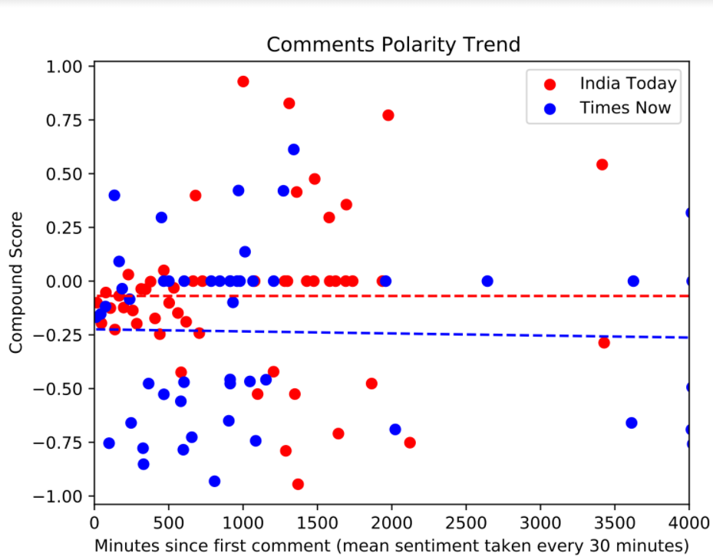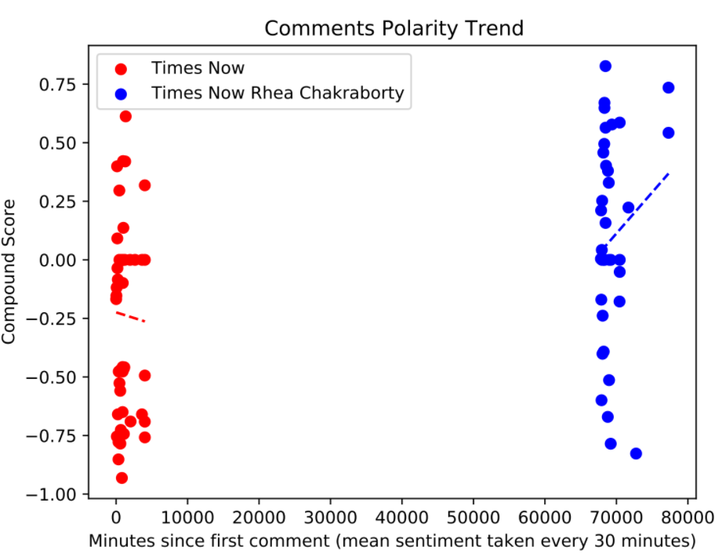

* YouTube

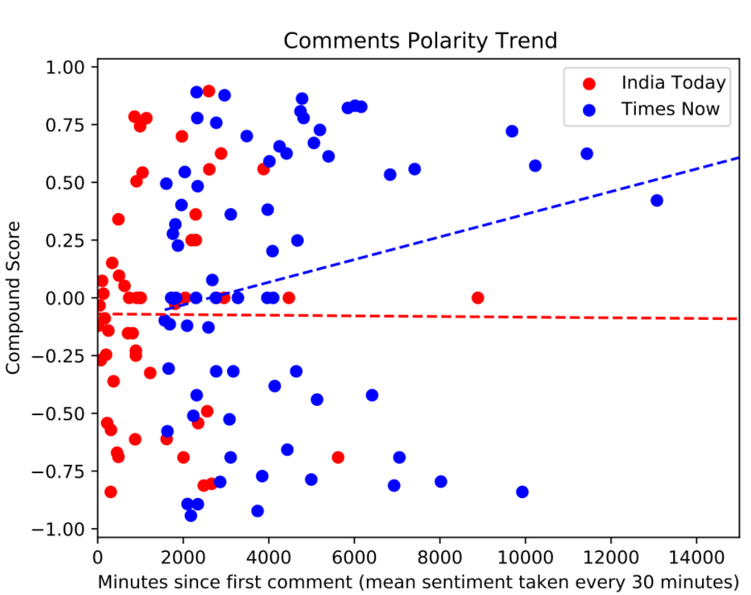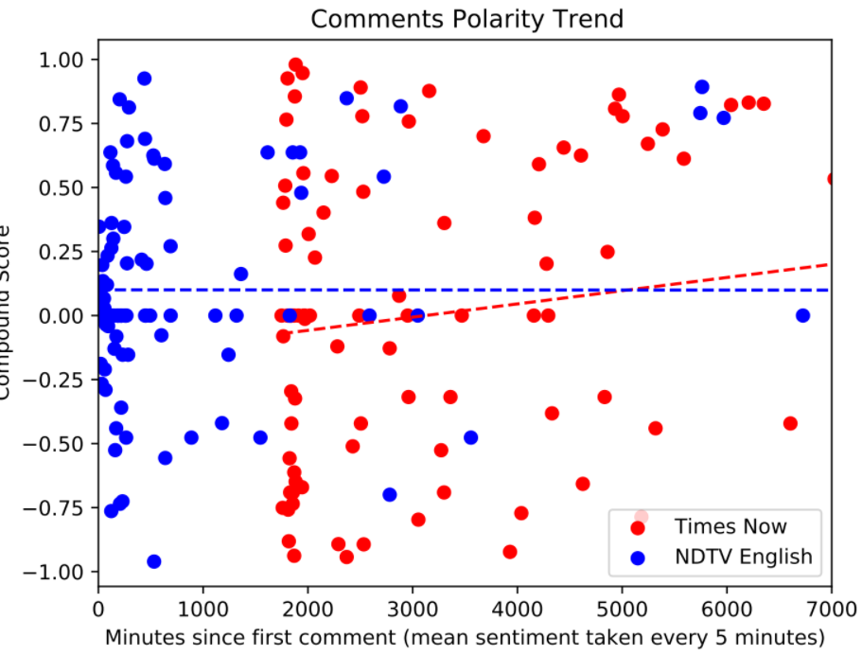

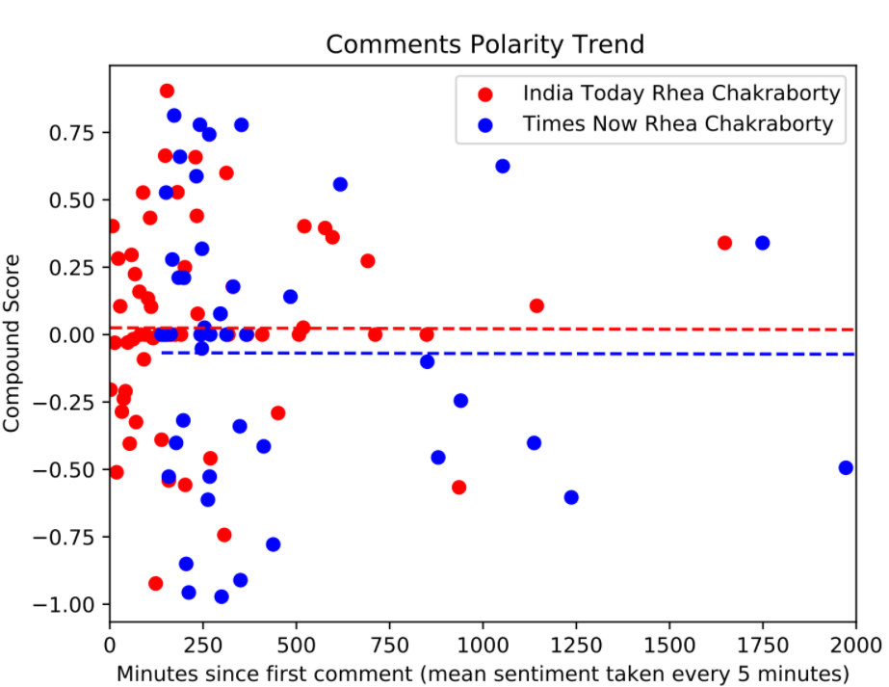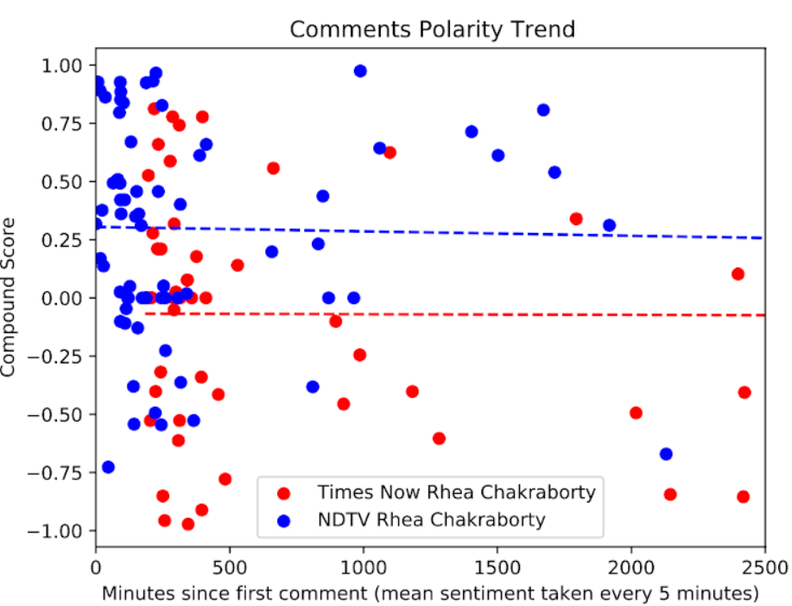

**Video Sentiments**

* Times Now YT: 4 people
  + Anchor - Don’t shed crocodile tears. Industry is a privilege club, don’t like outsiders, insecure, exclusivism. Capability and talent are different (in response to Komal). Anyone will adopt a capable actor if they attract an audience.
  + Vani Tripathi - we collectively failed him, brilliant boy, intelligent, conspiracy of silence. Anyone saying he had a failed career should rot in hell. SSR is a message that industry needs to get out of the incestuous net, need inward thinking.
  + Anand Ranganath - SSR searching for a library in a fish market. He was a misfit in Mumbai and unaware of it. Yes, nepotism exists everywhere but affects the film industry the most. Even though making films is a pvt enterprise, a failed person always gets more and more chances at the cost of someone talented. Does Not buy the argument that industry gives only what the p[ublic wants, as the public wants SSR’s movies. India is the land of the greatest stories ever told but someone needs to tell them.
  + Roopa Ganguly - Lovely child, beautiful mind, behavior didn’t change, humble. Cutthroat industry. Shouldn’t the people have helped him then? Instead people are writing things about him that he was wrong etc etc.
  + Komal Nahta - there is nepotism everywhere, hits aren’t made with nepotism
* India Today YT:
* India Today Rhea Chak YT: Is there a witch hunt going on for Rhea? Tough situation for Rhea charged with crimes. The facts will come out. “The electronic media has been unfair to me, propaganda against me” - Rhea. Rhea has to tell if SSR was depressed, pressured etc., because she was with him.
* Times Now Rhea Chak YT: Not taking sides. 3 people
  + Anchor - Why is there no need for CBI, if people aren’t satisfied, let them file further, they have the right (in response to Ravi). Why is there no cooperation by the Mumbai police, why haven't they filed FIR. Then why did the family change their stance now?
  + Swapnil Kothari - Bihar and Maharashtra state police are at loggerheads with each other. Best thing is to give the case to the CBI. After 40 days, the father of SSR isn’t satisfied with the proceedings which is why Bihar police filed an FIR. If Mumbai police choose not to cooperate, Rhea has the right to go to supreme court. Family might have been in shock at first.
  + Ravi Srivastav - there is no need for the CBI to handle the case. Everyone approaches the supreme court as if there isn't any other court. Everyone is involved as if this is a national case. Let the police investigate and do their job
  + Aniket Nigam - in response to why haven’t Mumbai police filed FIR, lets not get ahead of ourselves, we can’t conclude yet why. If SSR’s kin made similar allegations to Mumbai police that he made to Patna police, if not done there was no need for an FIR in the first place.
  + Shekhar Suman - CBI inquiry is imperative